COMMUNICATIONS UPDATE
communicate@blackburn.anglican.org


The new Dean of Blackburn
The Installation service for the new Dean of Blackburn, The Very Rev. Peter Howell-Jones, took place last weekend. You may have already seen the coverage on our website and social media channels and in the local media. If not here are some links to help you catch up …
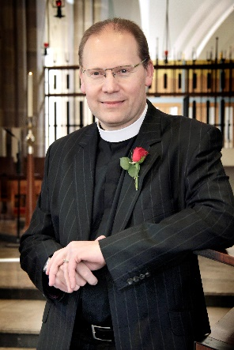
- Read the story on the Diocesan website here
- View a full album of pictures on Flickr by clicking here
- View service highlights and subscribe to our Diocesan YouTube channel here
- View a recording of the whole service taken from Facebook Live by clicking here and scrolling down the page to find it.
- Listen to the new Dean on BBC Radio Lancashire here (from 2h 09m 50s)
- Coverage appeared in several papers. Here’s an example from the Lancashire Telegraph
- View tweets from Saturday's event on Twitter @cofelancs - click here and follow our Twitter feed.
- Finally, you can still watch an introductory video filmed at the announcement of Dean Peter’s appointment here on the Diocesan YouTube channel
Ministry of Sport initiative is launched
Find out more about this new initiative and what it can offer your parish by reading the story about the launch which took place this month at Deepdale Stadium in Preston.
Discerning Women conference
For more on this conference which was held in the Diocese recently click here for a story about the event and to listen to BBC coverage.
Thy Kingdom Come - May 25 to June 4
There will be more about this event in the next edition of ‘Mission Matters’ - coming soon to parishes - but a reminder here that, as part of the 10 days of prayer, we are encouraging churches to open their doors, not just on a Sunday, but initially throughout the 10 day period, and hopefully beyond. An open church' toolkit is now on Diocesan website to give more practical advice. We have also designed a reusable, branded 'open church' banner for temporary external building use (or a ‘pop-up’ stand version for internal use). These will be available shortly at a subsidised price of £99 each (including VAT and delivery). If you want to order one you can express an interest in doing so now by emailing Karen Ashcroft with your details in the first instance on karen.ashcroft@blackburn.anglican.org
Blackpool Illuminations – new light display
Have you individually (or has your church collectively) given to this great initiative yet? If you want to know more click here to go to the information page and please be generous to help God’s light shine!
‘Standing Firm’ Youth Camp
‘Standing Firm’ is the theme for this year’s Diocesan Youth Camp which will take place at Hothersall Lodge Outdoor Education Centre on the weekend of June 9-11. A great team, including Bishop Geoff; staff from the Diocesan Board of Education and a fantastic group of dedicated young leaders will make sure the weekend is a fabulous experience for all attending. For more details and a booking form click here.
New Diocesan Youth Advisor

Ben Green arrives shortly to take up the post of Diocesan Youth Adviser and will be leading on the strategic development of work with, and activities for, our young people. Ben has plenty of experience already, having been the Youth Worker Chaplain at Bishop Rawstorne CofE Academy for the past few years. Read more about Ben and his work by clicking here.

‘Talking Jesus’ Northern Bishops’ Mission in Durham
Teams from our Diocese travelled further north to Durham Diocese earlier this month to participate in the ‘Talking Jesus’ Mission event. This was the latest Northern Bishops’ Mission – the last being Crossroads Mission in our Diocese in September 2016 of course. See who took part this time and find out how they got on by reading this story and following the links to other coverage.
… and finally
Here’s an encouraging story about one of our churches where no less than 20 people (17 of them young people) were confirmed recently!

Ronnie Semley
Diocesan Communications Manager

- This bulletin contains just a small snapshot of current news, activities and events taking place across the Diocese. Keep in touch by logging on to the Diocesan website and the Diocesan Board of Education website on a regular basis.

